**객체지향프로그래밍 과제**

1870034 류지현

5-4 InsOf.java

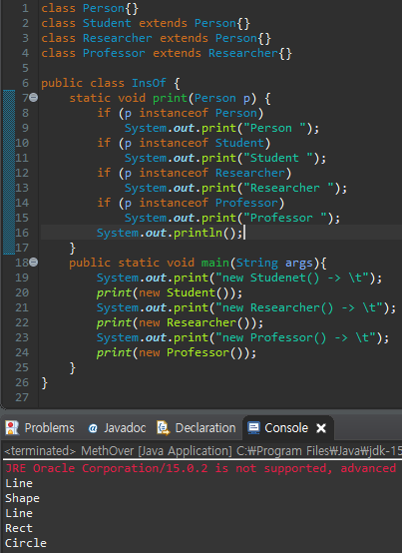

5-5 MethOver.java

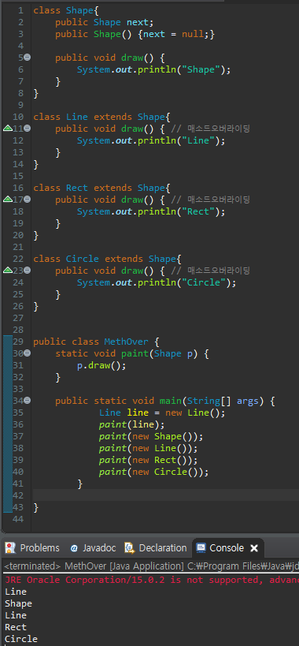

5-6 Overroding.java

5-7

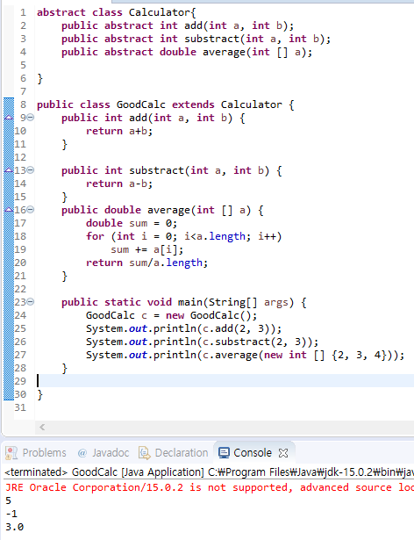

5-8

5-9